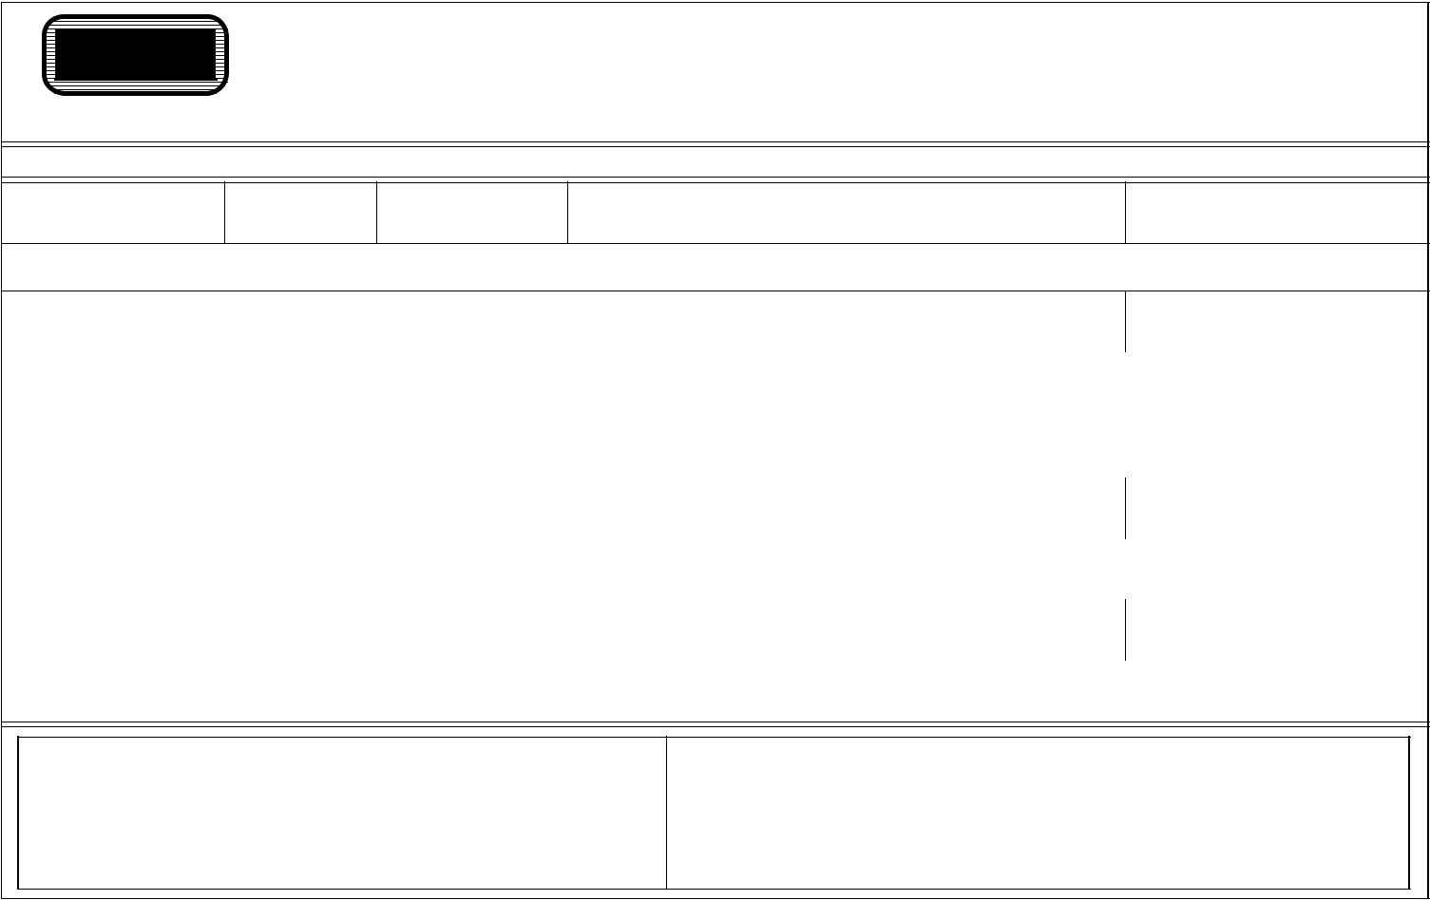
MOTOR VEHICLE BILL OF SALE

VEHICLE DESCRIPTION

PLATE NUMBER YEAR MAKE VEHICLE IDENTIFICATION NUMBER 4)4,%4.5-"%2

I transfer all rights, title and interest in the above described vehicle to:

NAME OF BUYER (PRINT LAST, FIRST, MIDDLE) | DATE OF PURCHASE
BUYER'S ADDRESS
PRINTED NAME OF SELLER (BUSINESS NAME IF SELLER IS A BUSINESS)
SIGNATURE OF SELLER (AUTHORIZED REPRESENTATIVE OF BUSINESS) | DATE OF RELEASE
X
PRINTED NAME OF SELLER
SIGNATURE OF SELLER | DATE OF RELEASE
X
SELLER‘S ADDRESS

● SELLER ●

You must provide notification to DMV of the sale within 10 days of the sale. (ORS 803.XXX)

● BUYER ●

If you do not apply for a title within 30 days from the date of purchase, you may be subject to a late title transfer fee.

